**Project Design Phase-II**

**Technology Stack (Architecture & Stack)**

|  |  |
| --- | --- |
| Date | 13 May 2023 |
| Team ID | NM2023TMID18886 |
| Project Name | Cancer Vision |

**Technical Architecture;**

* 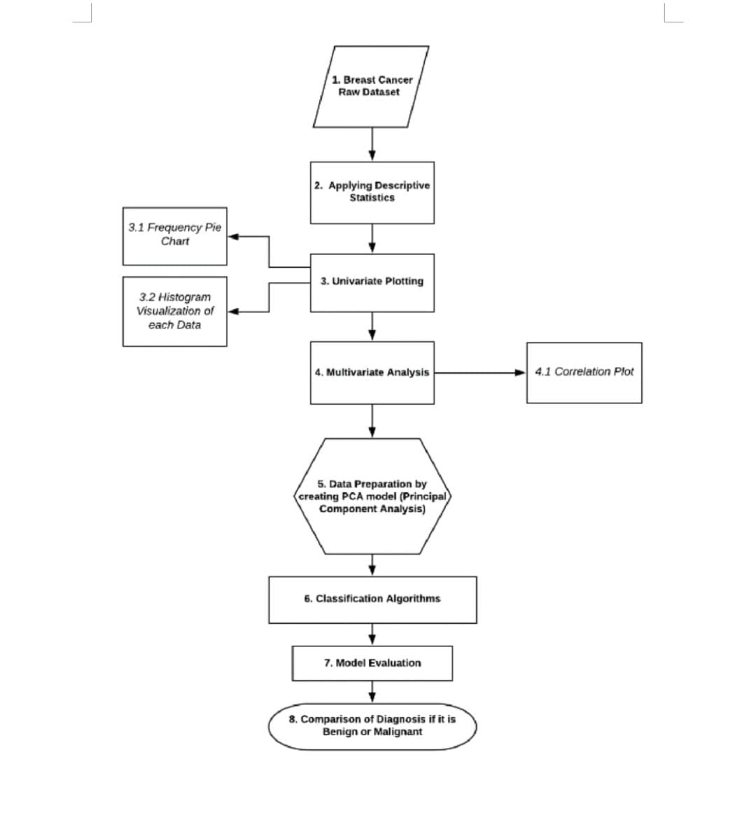

**Table-1 : Components & Technologies:**

|  |  |  |  |
| --- | --- | --- | --- |
| **S.No** | **Component** | **Description** | **Technology** |
|  | User Interface | Mobile app ,website | HTML |
|  | Application Logic-1 | Process through online application | Python |
|  | Application Logic-2 | Application though Website | IBM Service |
|  | Application Logic-3 | Logic for a process in the application | Programming technology |
|  | Database | Data Type | MySQL |
|  | Cloud Database | Database Service on Cloud | , IBM Cloud |
|  | File Storage | File storage requirements | Local file system |
|  | External API-1 | Purpose of External API used in the application | IBM Weather API, etc. |
|  | External API-2 | Purpose of External API used in the application | Aadhar API, etc. |

**Table-2: Application Characteristics:**

| **S.No** | **Characteristics** | **Description** | **Technology** |
| --- | --- | --- | --- |
|  | Open-Source Frameworks | First, the framework must be built to receive as input DICOM CT image files and produce as output a DICOM-compliant structure set file  Second, the framework must support both contour creation and CNN retraining on new data.  Finally, the framework must be built with tools to establish a browser-based interface for users without Python familiarity | DICOM CT,CONTOUR Creation |
|  | Security Implementations | Fire walls | End to end encryption |
|  | Scalable Architecture | Scalability of the Solution On a single-core processor, we obtained nearly linear scaling with an increasing problem size, whereas weak parallel scaling showed moderate growth in solving time relative to increase in problem size | Single core processor |
|  | Availability | promote prevention, improve early detection, manage care, and support survivors and chronic patients | Advanced technology and python coding |
|  | Performance | the highly accurate diagnostic performance, which is comparable to that of an endoscopist | PYTHON CODING |